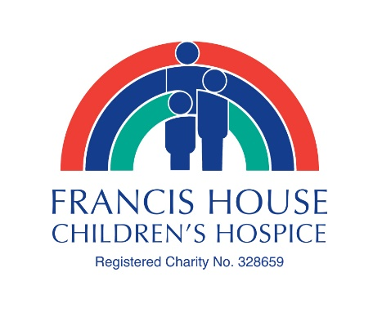
Great Manchester Run – Sunday 19th May 2019
Further information regarding running with Team Francis House

Thank you for your interest in supporting Francis House Children’s Hospice at the North West’s most popular running event. Join the unforgettable atmosphere along the route passing by Manchester’s favorite landmarks including Old Trafford Stadium, Imperial War Museum and Beetham Tower, lined with crowds of supporters cheering you on!

Following the success of the new half marathon distance in 2017, this option will return again. Choose between the popular 10k route or the more challenging half marathon.

The sponsorship money you raise with Team Francis House will help us continue our work caring for children, teenagers and young people with life-limiting conditions and offering essential support, friendship and encouragement to their families.

Register for one of our charity places
Register for one of our charity places by completing and returning the Registration Form, along with your discounted registration fee of £20 for the 10k route, or £25 for the half marathon route. Payment can be made by cheque payable to ‘Francis House Children’s Hospice’, in cash in person, or call the office to pay by card.

There is no minimum fundraising target, but please do try to raise as much as you can in sponsorship from your family and friends! Please print your email address clearly on the form; this address will be used for the charity to register your details online. You must click and confirm your details on the email you receive from the Great Manchester Run team to complete your registration.

Register through the Great Manchester Run website
Alternatively you can register online through the Great Manchester Run website - www.greatrun.org/great-manchester-run . The registration fee is £38 for the 10k and £44 for the half marathon. Don’t forget to click Francis House when you are asked which charity you would like to support.

Whichever way you register, we’ll be with you every step of the way. Our Fundraising Team will offer tips and guidance, plus materials including a free Francis House t-shirt or running vest, sponsorship forms, collection buckets, balloons and flags. We’ll also be there for you on the day in the ‘Charity Village’ helping you celebrate your achievement once you’ve crossed the finish line.

Thank you for your support, we look forward to welcoming you to Team Francis House!

Email: julie.williams@francishouse.org.uk Telephone: 0161 443 2200
www.francishouse.org.uk/great-manchester-run
Keep up to date - follow Francis House on Facebook and Twitter

