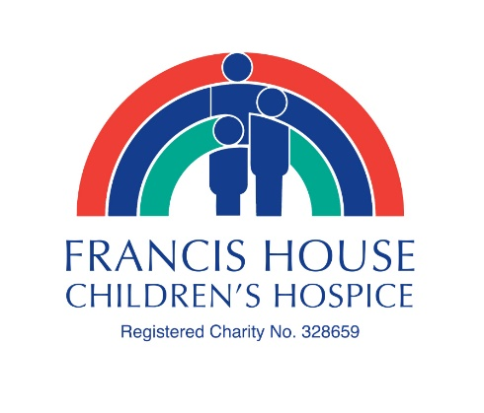

Great Manchester Run – Sunday 19th May 2019
Team Francis House – Charity Place Registration Form
I am registering for the (please circle)
10k distance Half Marathon distance
RUNNER INFORMATION
Name _______________________________________________________________
Contact Telephone ______________________________________________________
Email address ___________________________________________________________
Home address ___________________________________________________________
_________________________________________________________________________
Postcode __________________________________
Date of Birth ______________________________
Place of work _____________________________________________________________

ADDITIONAL INFORMATION
Please choose between a complimentary Francis House T shirt OR Running Vest ……....
(please circle your preference and size)
T shirt Size Small Medium Large Extra Large
OR Running Vest size X small (38”) Small (41”) Medium (43”) Large (46”) Extra Large (48”)

Are you running as part of a team? ____________________________________________
Have you previously taken part in any running events?
_________________________________________________________________________

Why have you chosen to run for Francis House?
_________________________________________________________________________
_________________________________________________________________________
_________________________________________________________________________
How did you hear about running for Team Francis House?
_________________________________________________________________________

KEEP IN TOUCH
Your support is vital and we would love to keep you posted with our news and activities. Your details will only be used by Francis House Family Trust. We will never give your information to other organisations to use for their own purposes. You are free to change your mind at any time. Please tell us if you would be happy for us to stay in contact with you following your Great Manchester Run.
By email |  |  | By post |  |  | By phone |  |  | By SMS

CONFIRMATION
I confirm that I (please print name) _______________________________ agree to take part in the Great Manchester Run 2019 and raise sponsorship from family and friends for Francis House Children’s Hospice. I understand this charity place is being offered to me at a discounted registration fee. I understand the importance of training and seeking medical advice before undertaking a training programme.

Signature ___________________________________ Date _________________

Please return your completed form by post or email along with your registration fee of £20 for the 10k or £25 for the half marathon. Payment can be made by cheque payable to ‘Francis House Children’s Hospice’, cash in person, or call during office hours to pay by card. |  | Francis House Children’s Hospice  Fundraising Office, 390 Parrswood Road, Didsbury, Manchester, M20 5NA  Julie.williams@francishouse.org.uk  0161 443 2200

Thank you for choosing to support Francis House Children’s Hospice!

